Final Project: Catalog

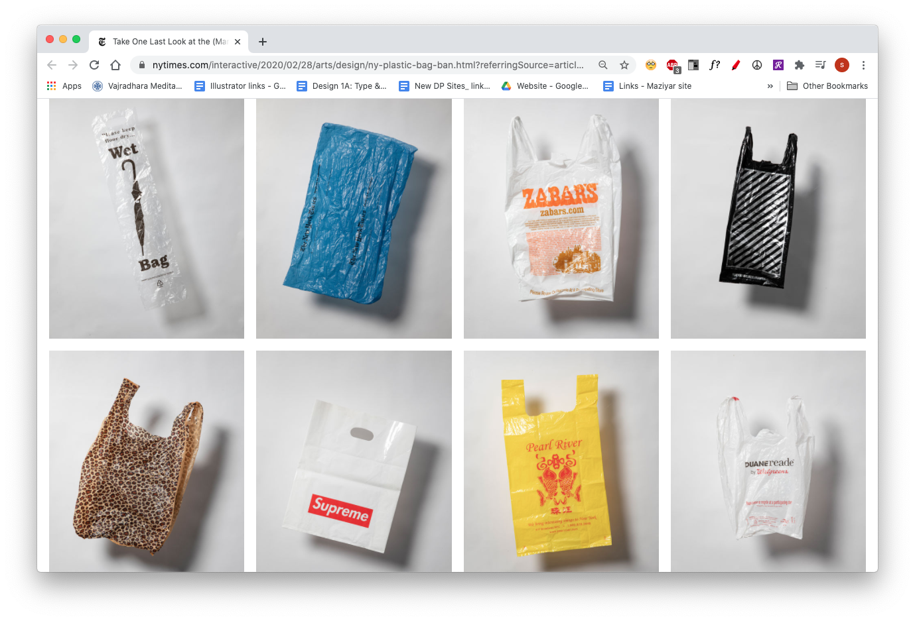

*Take One Last Look at the (Many) Plastic Bags of New York*, NY Times

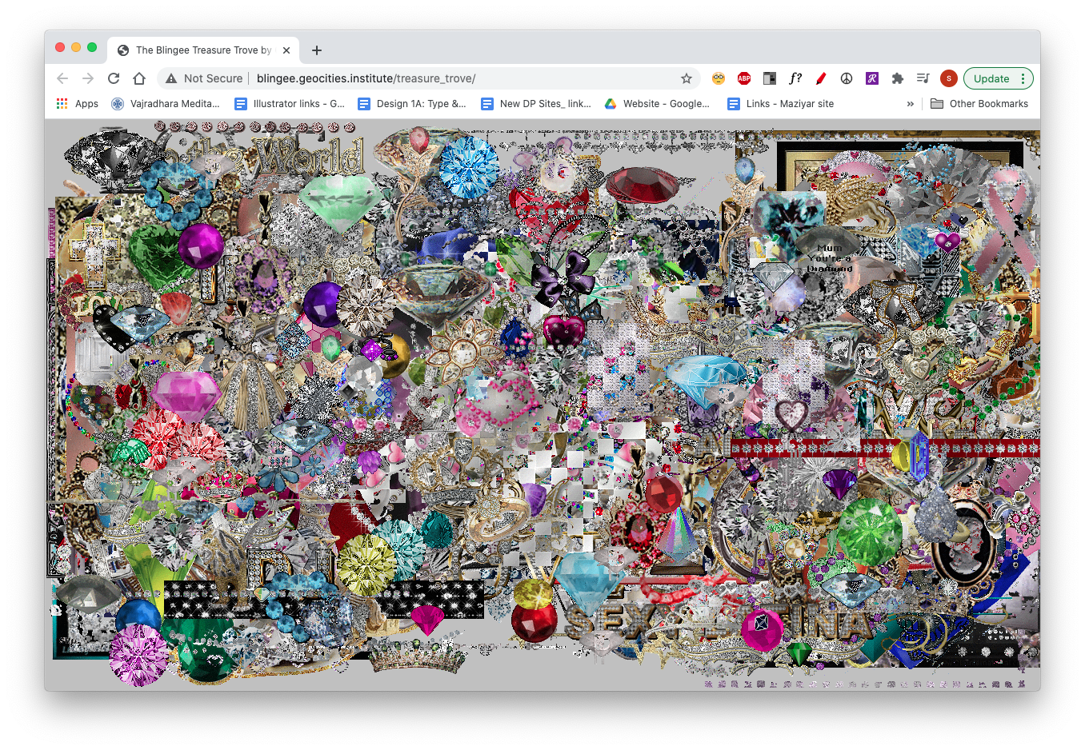

*The Blingee Treasure Trove*, Olia Lialina and Mike Tyka

PROJECT

Create a collection of 100 (visual) media items. These can be physical objects that you document, screenshots, found images, videos, original images, etc. If you want to collect quotes or text, it will have to be displayed with an image-based method.

We will add these into a database using Google Sheets, (you have the option to swap collections with one of your peers). We will then make an online experience that connects with the database in order to learn how to pull structured data that is not yours and use it to populate a website. (What is structured data? For example, on a recipe page, what are the ingredients, the cooking time and temperature, the instructions, etc).

OBJECTIVES

* Find a way for the type of content to inform the form of your site
* To gather and organize a collection of media
* To design flexibly for content that we can’t control
* To connect and use structured content from an API (Application Programming Interface)

CONSIDER

* WHAT do you want to do and WHY, and then HOW?
* Does the type of content imply a form for your site?
* How can you tell a story through a curated set of visuals / interactive experiences?
* How is the collection organized (or disorganized)?
* Consider how the user interacts with this collection, do they see it all at once, or do they have to work to uncover parts or all of it?
* Does the design of the site respond to new content? (e.g. marking anything that has been added in the last 24 hours)

REQUIREMENTS

* A title for your collection
* An about page or section containing a brief text about your collection + designer credit
* Must include all 100+ media items
* Your site must have one javascript element that enhances the experience and relates to your collection in a meaningful way.
* Your website should have at least two ways of viewing your collection.
* These can be filters/subgroupings, sorting methods, list v thumbnails toggle, etc.
* Site favicon
* Must be responsive / functional on a mobile screen (mobile does NOT need a custom design, however, but the site should not break on a mobile screen.)

INSTRUCTIONS

PART 1 (due 10/29)

1. Come up with 3 ideas for a collection with 5 images/media items/examples for each. (example set of three themes: screenshots of my desktop, video clips from the news, or cut out images of doll body parts).
   * Consider what unites the media, how different or similar can they be from each other?
   * You don’t have to know why you like something or where this is going!
2. For each, write a summary (one or two sentences) of what you’d like to investigate with the collection idea.
3. Display all of this in this [Google Slide document](https://docs.google.com/presentation/d/1gG9mkPTdc4xCGwAV_O3W5NYvRi45uM-JIqG0XqoR8lY/edit?usp=sharing).

PART 2 (due 11/21)

1. Create a folder that bears your name in the Google Drive folder: [Final-Project-Student-Folders](https://drive.google.com/drive/folders/1ievEpJ9EoGKOtAZeCRSJ7m4rhUIHJ6C-?usp=drive_link). Come up with three layout ideas for your website.
2. Consider ways that you might organize the 100 items. Come up with multiple ideas for a set of 3 sub-categories. These might be [filtering](https://karolinapietrzyk.info/) or [sorting](https://www.experimentaljetset.nl/) mechanisms. Find similarities, draw connections, and develop a concept or narrative for the collection you chose.
3. Present sketches of 3 vastly different ways of viewing/designing your assigned collection using Sketch, XD, Figma, or Indd.

* Can you look at one item at a time, or is the overall-ness important?
* How does the user move between the items in your collection?
* How do the filters/sorting mechanisms function?

1. Add the sketches to your Google Drive project folder: [Final-Project-Student-Folders](https://drive.google.com/drive/folders/1ievEpJ9EoGKOtAZeCRSJ7m4rhUIHJ6C-?usp=drive_link).

PART 3 (11/28)

1. Finally, choose your design direction and **start building** it out in code according to your chosen design – using the resources and lectures made available to you this semester.

PART 4 (due 12/18)

Final deliverables due.

REFERENCES: PART 1

You all know what a collection is but here are some fun examples:

*Of Data*

* [Hidden Life of an Amazon User](https://www.janavirgin.com/AMZ/amazon.html), Joanna Moll
* [EverythingIveAlwaysWantedtoKnow.com](http://everythingiveeverwantedtoknow.com/), Martine Syms, 2007

*Of Documented Objects/Things*

* [Gifts from CyberSpace](https://www.nytimes.com/interactive/2020/12/10/style/gifts-from-cyberspace-2020.html), NY Times
* [The Bureau of Suspended Objects](https://www.suspended-objects.org/), Jenny Odell, 2015–ongoing
* [Used Lipstick](https://stacygreene.com/portfolio/lipsticks/), Stacy Greene, 1992
* [An Index of Patriotic Consumption](https://www.hectorrene.com/an-index), Hector René Membreño-Canales

*Of Original Photographs/works*

* [An iphone Tour](https://johncaserta.com/introletter.html), John Caserta
* [Agency of Unrealized Projects](https://aup.e-flux.com/), Hans Ulrich Obrist, Julia Peyton-Jones, Julieta Aranda & Anton Vidokle Hans Ulrchic (2012 – )

*Of Found Images*

* [dinakelberman.tumblr.com/](https://dinakelberman.tumblr.com/)
* [9-eyes.com/](http://9-eyes.com/), John Rafman, 9-eyes, ongoing
* [Thousand Little Brothers](https://elahi.gmu.edu/), Hasan Elahi, 2014

*Of Text/Narratives*

* [websafe2k16.com](http://websafe2k16.com/)
* [Words that Make me feel](https://www.are.na/shayla-angeline/410285), Shayla Angeline’s Are.na channel
* [I got up](https://www.moma.org/collection/works/186378), On Kawara, 1977

*Of Sounds*

* [Introduction/City Street Sounds/People Sing, Dance and Pray](https://www.youtube.com/watch?v=TesEGllSUgA&), Tony Schwartz, 1956
* [Moss Playlists](http://moss.org.uk/)
* [Xeno-Canto bird sounds archive](https://www.xeno-canto.org/explore?dir=0&order=xc)

REFERENCES: PART 2

*Design*

* [Take One Last Look at the (Many) Plastic Bags of New York](https://www.nytimes.com/interactive/2020/02/28/arts/design/ny-plastic-bag-ban.html?referringSource=articleShare), NY Times
* [AD 93](https://ad93.ltd/), music label
* [Dictionaryofonlinebehavior.com](http://dictionaryofonlinebehavior.com/index.php)
* [typical-subjects.com](http://www.typical-subjects.com/), Matt Wolf
* [Experimentaljetset.nl](https://www.experimentaljetset.nl/preview), portfolio site
* [Whispersgame.com](http://whispersgame.com/), gallery site
* [The Blingee Treasure Trove](http://blingee.geocities.institute/treasure_trove/), Olia Lialina and Mike Tyka
* [Zen For Film](http://bgcdml.net/revisions/app/exhibition-history/), Linked by Air / Laurel Schwulst
* [Allmyfriendsatonce.com](https://allmyfriendsatonce.com/#0) by Laurel Schwulst
* [Library of the Printed Web](https://printedweb.org/) (2013), Paul Soulellis
* [Cyberfeminism Index](https://cyberfeminismindex.com/) by Mindy Seu

*Filtering*

Research various websites that use filtering in an interesting way. Save it to your are.na channel

*Sorting*

Research various websites that use sorting in an interesting way. Save it to your are.na channel